**Carrizo Plains effects of cattle grazing on vegetation**

Prepared by Alejandro Brambila and Lauren Hallett

July 2018

Cattle grazing has the potential to substantially alter plant communities through biomass removal, selective grazing and trampling. Here, we look at three categories of vegetation response to grazing in Carrizo Plains, an arid grassland in southern California: (A) change in percent cover of native and invasive species, (B) change in residual standing biomass after cattle grazing, and (C) change in Shannon diversity of the plant community.

1. *Effects of grazing on native and exotic cover.*

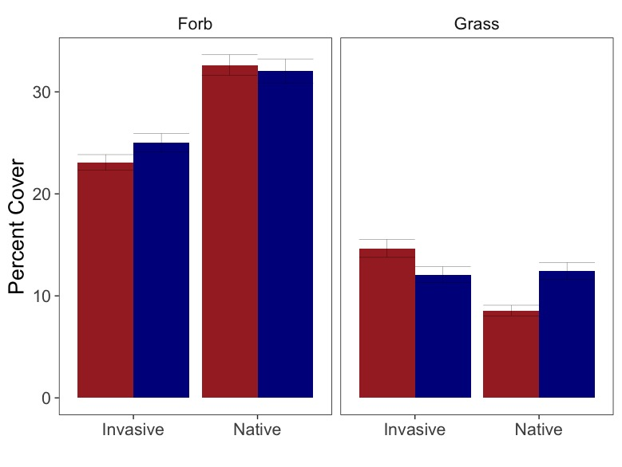

*

Figure 1. Comparison of percent cover (±SE) for twenty paired plots in the Center Well pasture. Ten plots were grazed (red) and ten were not grazed (blue). Percent cover for each treatment is calculated by using the means of quadrat-level percent cover for both native and invasive (exotic) forbs and grasses. Only years that were grazed (see colored bars in Figure 2) were included in average and statistics. Significance was calculated using a mixed-effects model with quadrats nested in plots and year as a random effect and post-hoc Tukey tests. Error bars represent standard error. The only significant effect was a reduction of native grass cover in grazed plots when compared to ungrazed plots (marked with asterisk, p=.0216).

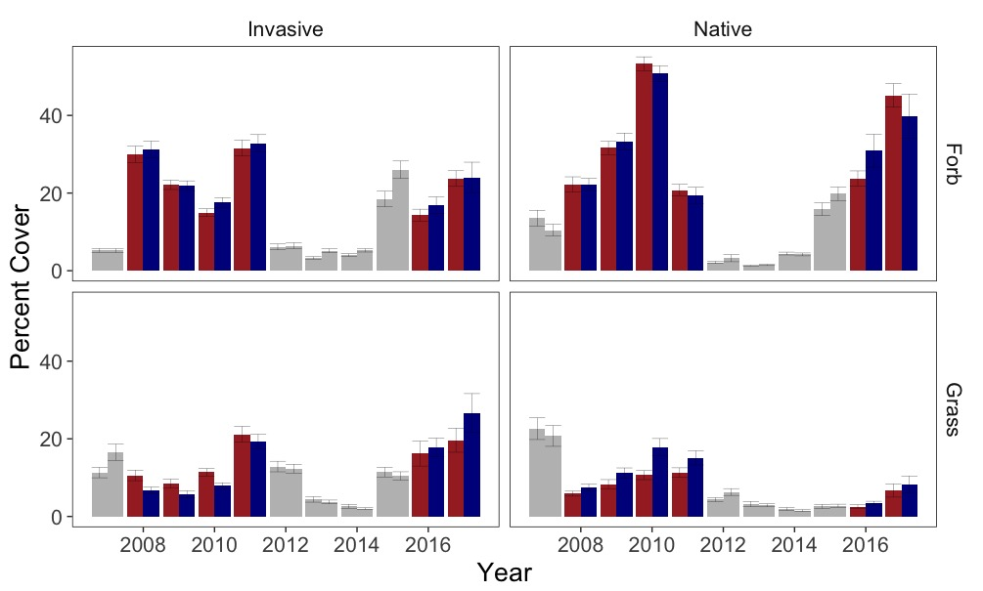

Figure 2. Annual comparison of percent cover for twenty paired plots in the Center Well pasture. Ten plots were grazed (red) and ten were not grazed (blue). Percent cover for each treatment is calculated by using the means of quadrat-level percent cover for both native and invasive (exotic) forbs and grasses. Error bars represent standard error. Grey bars represent years that were not grazed, including the California drought (2012-2015). Consistent reduction of native grasses by grazing can be seen. Population does not recover after the drought like invasive grasses do, potentially influencing the shift in directionality of grazing effect on invasive grasses seen in years 2016 and 2017 as cattle shift from preferred native grasses to invasive.

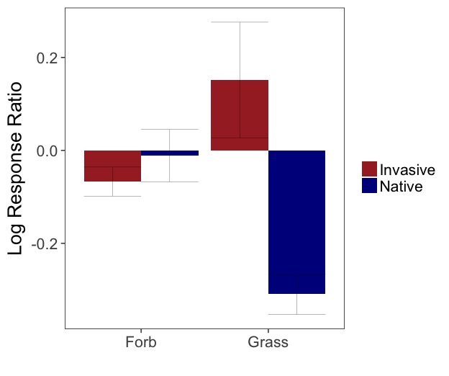

Figure 3. Log response ratio of precent cover from grazing effects on data from Figures 1 and 2: log(grazed/ungrazed).

*(B). Grazing effect on residual biomass.*

All year model

No-2017 model

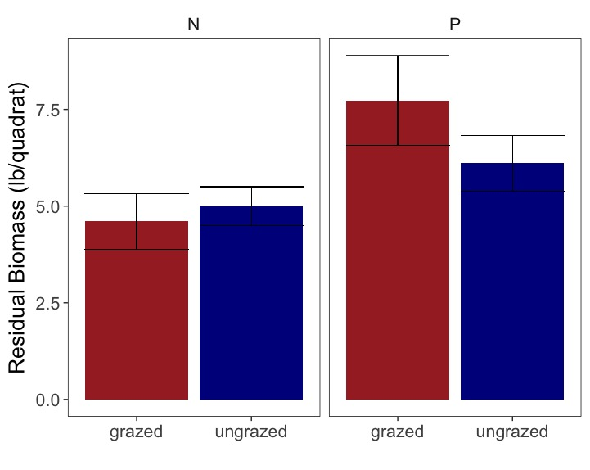

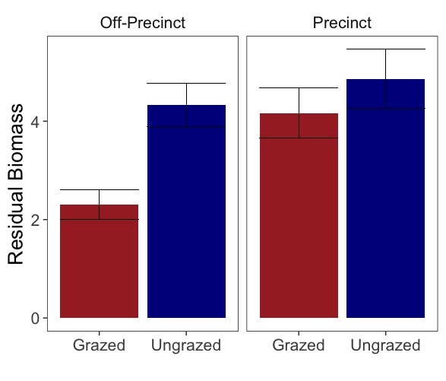

*

Figure 4. Comparison of residual biomass measured in October for twenty paired plots in the Center Well pasture. Ten plots were grazed (red) and ten were not grazed (blue). For the left panels, only years that were grazed (see colored bars in Figure 2) were included in average and statistics. For the right panels, the highly variable and heavily productive outlier year 2017 (see figure 5) was removed from average and statistics. Significance was calculated using a mixed-effects model with quadrats nested in plots and year as a random effect and post-hoc Tukey tests. Error bars represent standard error. In the all year model, no effects were significant. In the no-2017 model, grazing was significant off precinct (marked with asterisk, p=.0217).

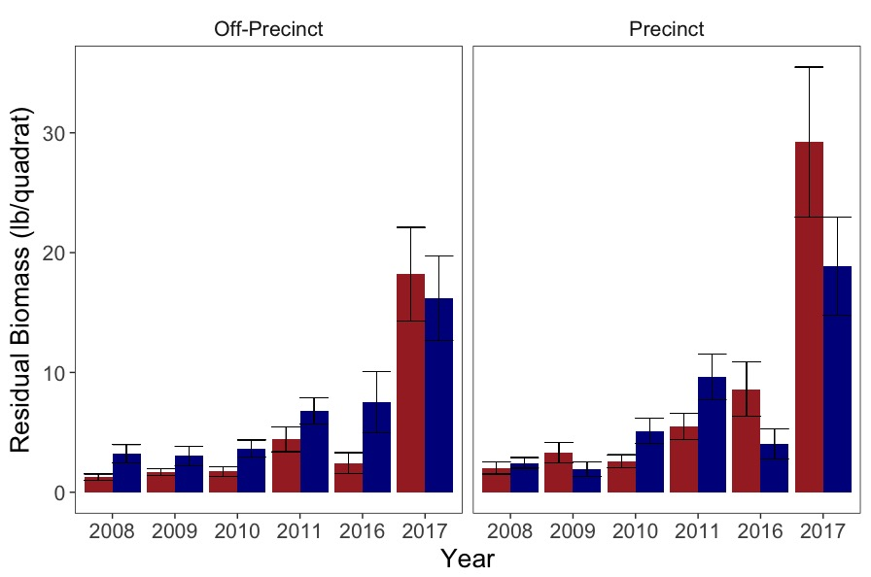

Figure 5. Annual comparison of residual biomass measured in October for twenty paired plots in the Center Well pasture. Ten plots were grazed (red) and ten were not grazed (blue). For the left panels, only years that were grazed (see colored bars in Figure 2) were included in average and statistics. In 2017, heavy rains led to extremely high productivity, and no meaningful difference between treatments. Removed as an outlier, consistent reduction of residual biomass by grazing can be seen off precinct, while no pattern is seen on precinct.

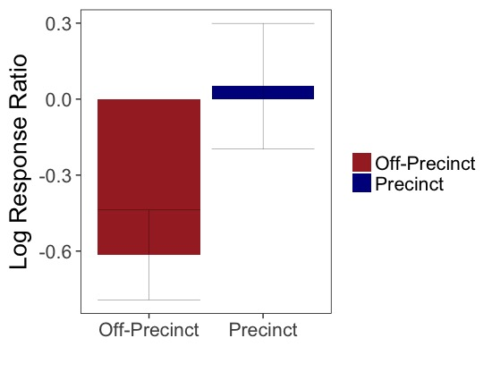

Figure 6. Log response ratio of grazing effects on all-year data from Figures 4 and 5: log(grazed/ungrazed). Same strong reduction pattern shown as Figure 5.

*C. Grazing effect on diversity*

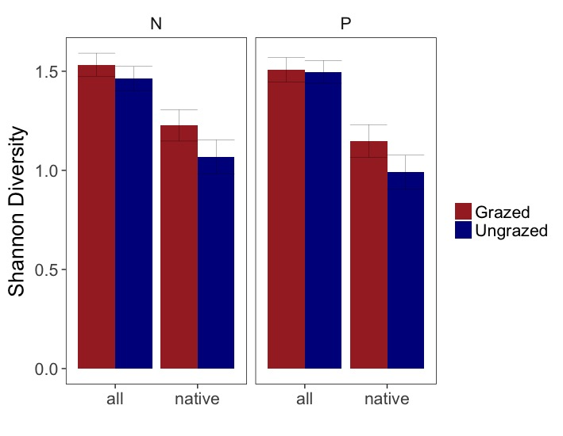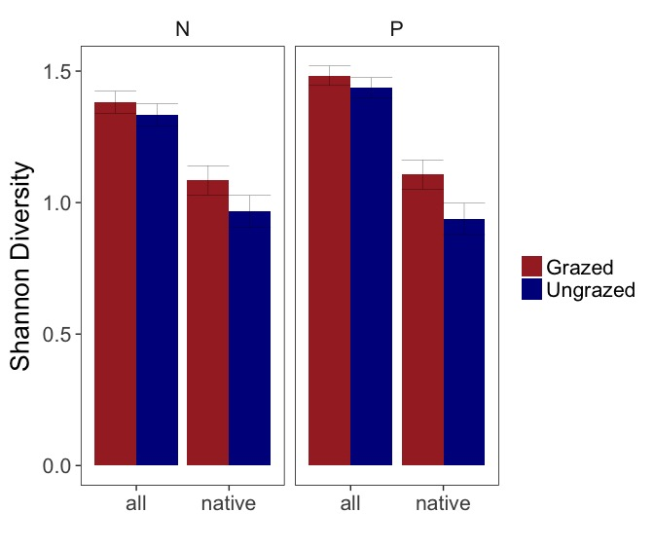 Post-Grazed Years All Years

*

Fig 7 – Shannon diversity at the plot level calculated on species counts summed across quadrats within a plot. Since diversity counts occur in the spring before cattle go on, only years following grazed years are included in analysis (2009-2012, 2017. left panel). While cattle seem to increase diversity of native plants, mixed effects model and Tukey showed no significant impact of grazing treatment, although the effect was meaningful (asterisk) when ungrazed years were included in analysis (right panel).

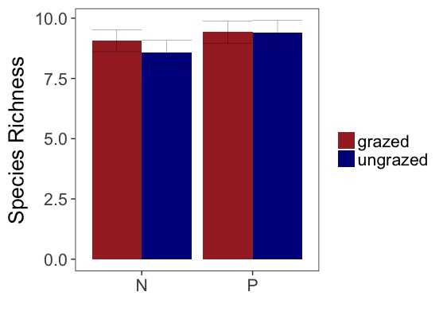

Fig 7 – Species richness at the plot level with total number of species summed across quadrats within a plot. Since diversity counts occur in the spring before cattle go on, only years following grazed years are included in analysis (2009-2012, 2017). No significance.